Constructing a video laser display

Lana Petrovečki, Igor Bosanac, Ina Galić

# Introduction

A laser display is a device that projects pictures by using lasers. We made our laser display by using two speakers, two small mirrors and a laser pointer. Our laser pointer shoots a laser beam onto the mirror on the first speaker which then reflects onto the mirror on the second speaker and in the end projects onto a display. To create complex pictures, and not just a dot on the wall, we use frequencies so that speakers make sound waves which cause the mirrors to vibrate.

Figure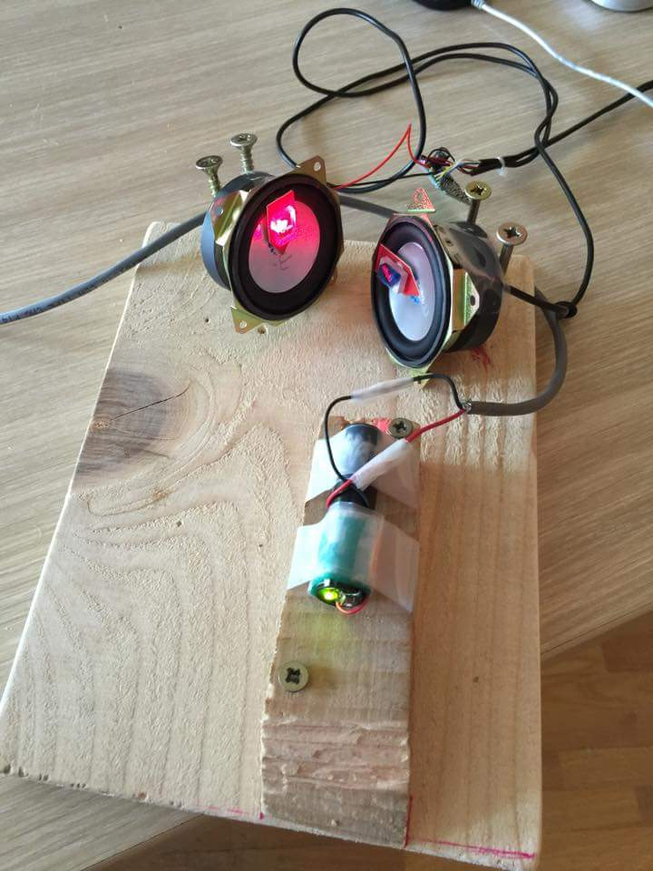 1: an example of a laser display device.

The basic movement that the mirrors make in those conditions consist of sine and cosine waves. With those functions we can create Lissajous curves, which are patterns formed by two harmonic vibrations. One vibration (played by the first speaker) moves vertically while the other vibration (played by the second speaker) move horizontally. The two vibrations act as the orthogonal x and y axis, meaning that the angle between them is 90 degrees. The formula used for the Lissajous curves goes as follows:

$x=Asin\left(at+ϕ\right)$ $y=Bsin\left(bt\right)$

The *A* and *B* in the formula are two magnitudes of the harmonic vibrations, *a* and *b* are the two frequencies and ϕ is their phase difference. Time is represented by the letter *t*. In our experiment, we can control *A* and *B* by changing the volume of the speaker, *a* and *b* by changing the tone frequency and ϕ by shifting the start of the waves in a certain program (e.g. Audacity).

# Methods and progress

Knowing the theory behind our project was the base to start making more complex pictures. But before we could do all that, we had to build our displays. While seemingly easy to build, positioning the mirrors in the right places on the speakers proved to be exceptionally challenging. The reason for it being so hard is because it is hard to predict how the mirror's placement on the speaker will affect its vibrations: the placement of the mirror is crucial because the speaker’s membrane moves in all kinds of directions while we want it to move in only one. Positioning the speakers was also one of the things that we had to keep in mind. When the laser beam reflects from the first vibrating mirror, it creates an arc in a certain direction which spreads onto a larger area. Moving the mirrors closer to each other will allow us to have more precise pictures.

Figure 1: An example of a Lissajous curve; in this case, the ratio a/b is 7/6.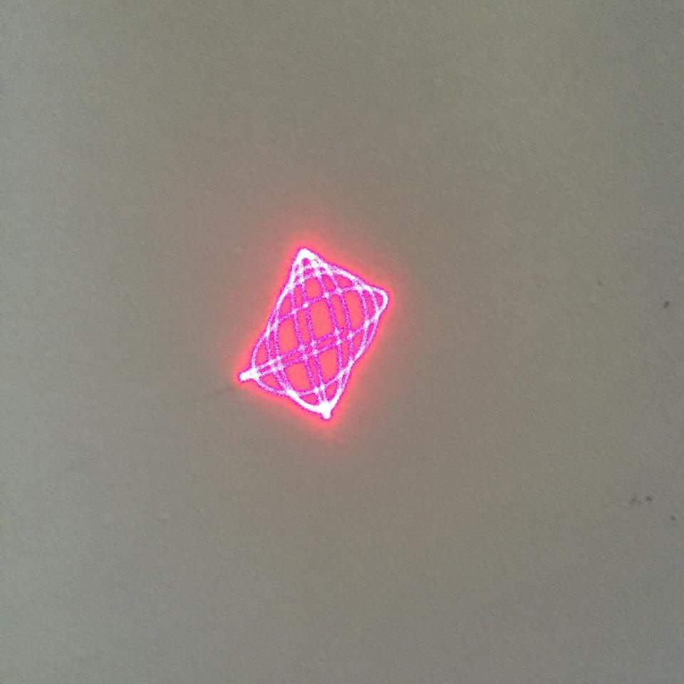

# Testing the speakers

Each mirror vibrates in 2 directions: vertical and horizontal. The movements of the speakers create various simple images, e.g. a straight line or a circle. If on the certain frequency the laser creates a line, it means that the speaker is moving in just one direction, or to be precise, only on one axis. By moving in two directions (two axes), the beam creates curves. If we change the ratio of the two frequencies, it’s possible to create circles, or at the end, Lissajous curves.

In order to get proper control over Lissajous curves, we want the mirrors to move in orthogonal directions with the greatest possible amplitude. Thus, to get the most precise picture we had to find the optimal resonance frequency for each speaker.

Resonance is a phenomenon in which the mirror on the speaker vibrates the most in a certain frequency and direction. The resonance frequency depends on the mass and size of the mirror, as well as where it is placed on the membrane. To find the resonance frequency, we measured the length and width of the arc projected by the laser, staring from 0 to 1600 Hz in jumps of 10 to 25 Hz. The measurements were saved and processed in Excel. The next step was to draw graphs and test the new found frequencies that were meant to project the best picture. For some devices experiment worked well and we received the promised results; for others the mirrors proved to be not optimally placed and could benefit from adjustment.

Figure 1: A good resonance response curve. The x axis is frequeny in Hz, the y axis is arc length in cm. Blue is x direction, orange is y direction.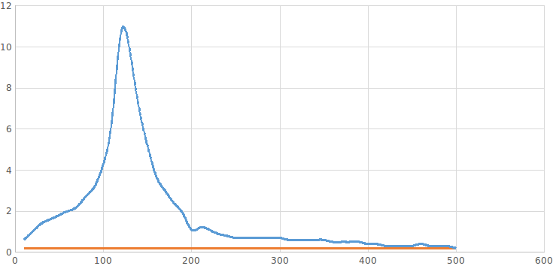

The Lissajous curves we made after finding optimal frequencies were nice looking, but we wanted to create something more complex. For doing that, we used Arduino.

Figure 1: A less optimal resonance response for another speaker. Colors and axes same as previous figure.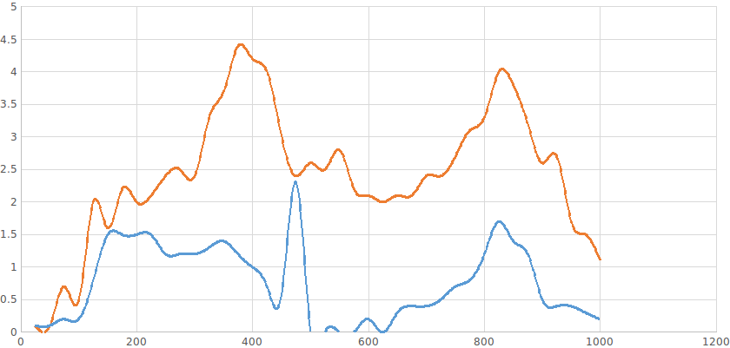

# Arduino

Arduino is both a microcontroller device and a programming language. With Arduino we managed to switch the laser on and off at certain times so the picture that the laser display device projected wasn’t a continuous line anymore, but there were also some empty spots. Then we experimented a little bit to see how we can change pictures that our laser device projected. Our goal was to get a pixelated picture, and in order to achieve our goal we needed to calculate at exactly what points we had to turn the laser on and off. This involved calculating when, in time, the laser would reach certain points in a closed Lissajous curve.

We then encountered a second problem: Our projected picture wasn’t identical every time we started the program, because the Arduino turning the laser on and off was not synchronized with the speakers eminating the sound. To fix this, we had to make both the program and sound start at the same time. To do so, we combined code in Python (a programming language) with the code in Arduino and managed to do so. The code in Python sent a message in the computer's serial port that acted like a trigger for the sound and the laser to turn on at the same time.

# Conclusion & final goals

Arduino made our life so much easier. By using Arduino, we made **awesome** pixelated pictures using only Lissajous curves and a simple program which helped us control the laser beam and curves. Unfortunately, we reached only half of our goal – we still didn’t make as complex pictures as we wanted. In order to do that, we would have to make our program a bit more complicated – it would do our Lissajous-pixel calculations for us. We would also have to play around with the speakers to find the right position of the speaker/mirror. In general, it was really fun working on the project and seeing all the abilities of a home-made video laser display.

# Thanks

We would like to thank Summer School of Science for giving us the opportunity to work on this awesome project and to help us discover all its beauty. Special thanks to our project mentor Renan Gross for letting us discover the passion for science and for being such an amazing and patient person.